Cryptocurrency Price Tracker – Project Report

Automated Real-Time Cryptocurrency Data Extraction and Tracking

Author: SANDHIYA R(Team 1),
Project Type: Individual Project

EXECUTIVE SUMMARY
The Cryptocurrency Price Tracker project demonstrates an automated system that scrapes real-time cryptocurrency data from the CoinMarketCap website using Python and Selenium.
The system solves the problem of manually monitoring frequently changing crypto prices by automatically collecting, storing, and updating relevant market information.
The tool extracts essential attributes such as coin name, current price, 24-hour change, and market cap, and logs the data into a structured CSV file for further analysis.
This project is highly useful for investors, analysts, and researchers who need reliable, time-stamped crypto market data.

PROJECT OVERVIEW

Objective

To build an automated tool that:
- Extracts live cryptocurrency prices from CoinMarketCap
- Tracks changes in cryptocurrency values over time
- Stores the output in a structured CSV format for analysis

Scope
- Real-time price tracking for top cryptocurrencies
- Automatic extraction using Selenium (handles JavaScript-loaded pages)
- CSV export for trend analysis
- Timestamp logging
- Market data monitoring

Key Features
- Live Price Scraping: Extracts up-to-date crypto prices
- Dynamic Page Handling: Uses Selenium to load JavaScript content
- Top 10 Coins Data: Collects name, price, 24h change, and market cap
- CSV Export: Stores all data with timestamps
- Historical Tracking: Helps monitor price movement over time
- Headless Mode: Can run without opening a visible browser

TECHNICAL IMPLEMENTATION

Architecture
The system follows a simple automated pipeline:
- Website Loading: Selenium opens CoinMarketCap
- Real-Time Data Fetching: Waits for JavaScript elements to load
- Data Extraction: Scrapes top 10 cryptocurrencies
- Data Processing: Organizes coin details
- Logging: Appends timestamped records into a CSV file
- Output Generation: CSV file ready for analysis or dashboards

Technology Stack
- Python 3.x – Core language
- Selenium – Browser automation & scraping
- ChromeDriver / WebDriver Manager – Chrome interaction
- Pandas – Data storage and CSV manipulation
- Time & Datetime Modules – Delay handling & timestamps

REAL-WORLD PROBLEM SOLVED
Cryptocurrency prices change every second, making it impossible for users to manually track price movements accurately. Investors need real-time, reliable, and historical price information for decision-making.

This project solves:
- The difficulty of manually refreshing crypto websites
- Lack of historical price records for analysis
- Time-consuming and error-prone manual tracking
- Inability to monitor multiple coins simultaneously

Impact:
- Saves time
- Provides accurate, time-stamped crypto data
- Helps in trend analysis
- Useful for traders, investors, and researchers

PERFORMANCE METRICS
- Top 10 coins extracted per run
- Execution time: ~5–10 seconds
- Output: Clean, structured CSV files
- Reliability: Works consistently with JavaScript-loaded pages

SOURCE CODE IMPLEMENTATION:

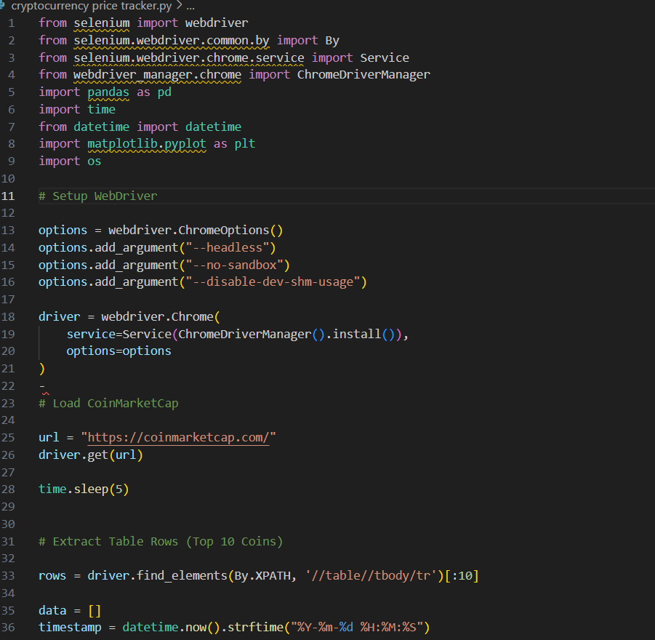

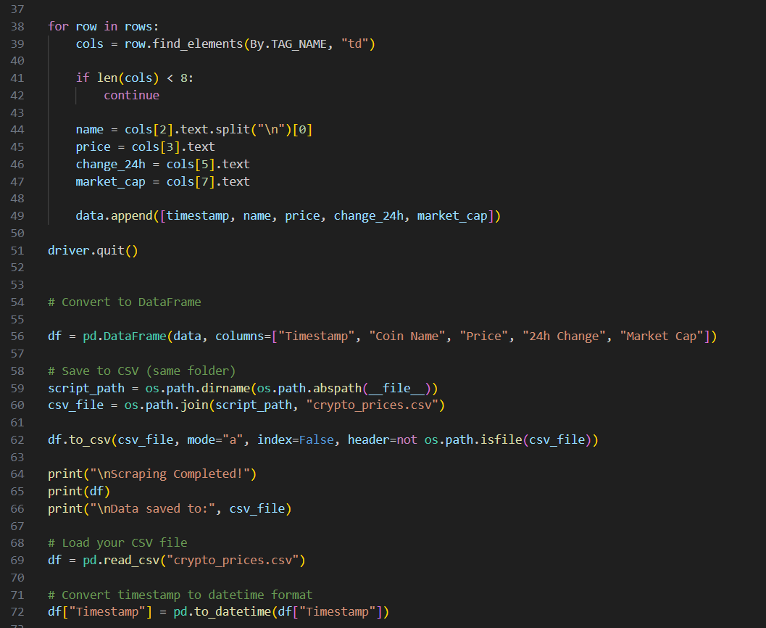

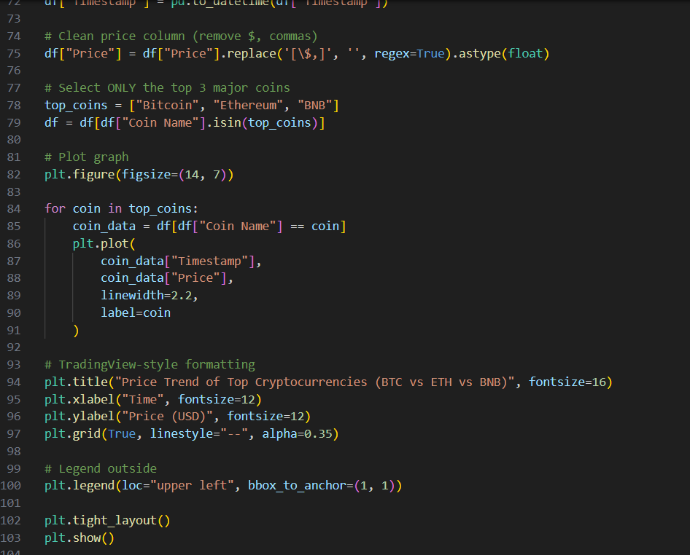

EXTRACTED RESULT IN EXCEL:

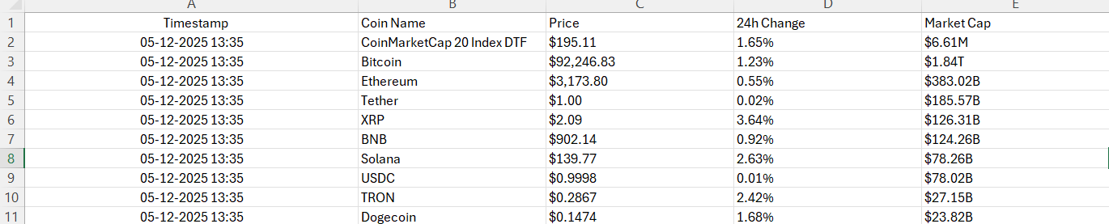

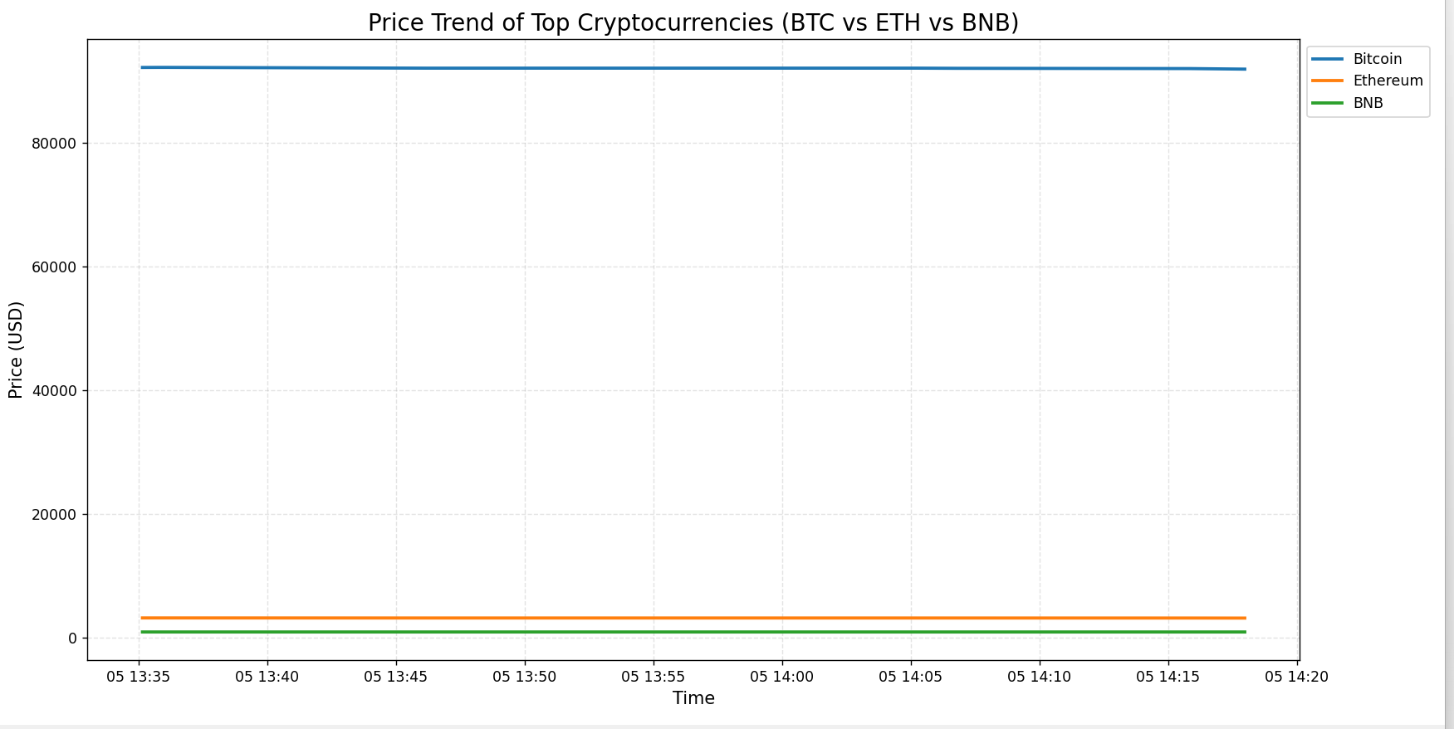

KEY ACHIEVEMENTS

Technical
- Automated JavaScript-based web scraping
- Clean and structured data export
- Successful Selenium integration
- Reliable real-time price extraction
- Timestamps for historical tracking

Process Benefits
- Eliminates manual checking
- Ensures consistent data collection
- Enables offline analysis through CSV
- Can be scaled to scrape more coins

LIMITATIONS AND CONSTRAINTS

Current Limitations
- Only scrapes CoinMarketCap
- Requires stable internet connection
- Dependent on website structure (changes may break scraping)
- Not a real-time continuous monitor unless placed in a loop

Resource Constraints
- Limited to CSV storage (no database)
- Processing speed depends on Selenium & browser

PROJECT IMPACT AND VALUE

Immediate Benefits
- Time savings in market monitoring
- Accurate and structured data collection
- Supports decision-making for traders
- Helps in academic and market research

Long-Term Use
- Can be extended to dashboards
- Useful for forecasting models
- Ideal for crypto market analysis

10. CONCLUSION
The Cryptocurrency Price Tracker project effectively automates the process of collecting and storing real-time cryptocurrency data. It demonstrates strong skills in web scraping, browser automation, data extraction, and data processing.
The solution helps users overcome the difficulty of manually tracking fast-changing crypto prices and provides a foundation for advanced analytics and visualization.

